# Managing Value Stream

## Login to site

Open browser and type Url <https://gabrielny.sharepoint.com/sites/gabrielteam> It will show Microsoft login page. Provide Credentials and it will redirect to Home page of site. 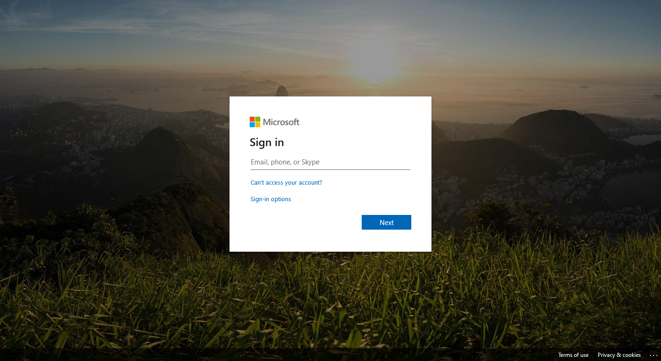

## Update colours

1. Go to wiki home page and click on “Edit” button. 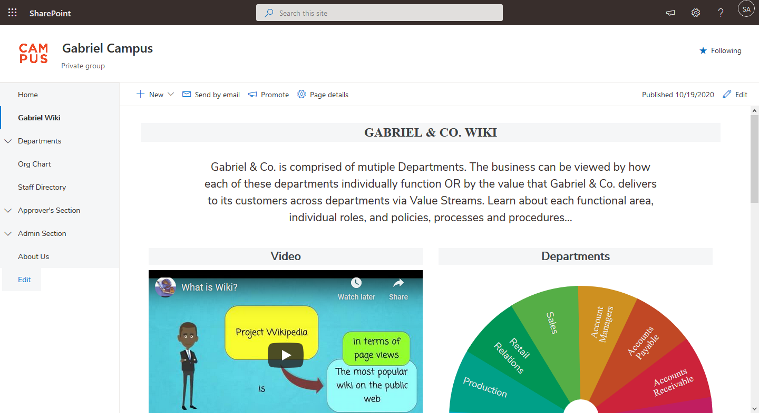
2. It will open page in edit mode. Click on 2nd “Edit snippet” button. 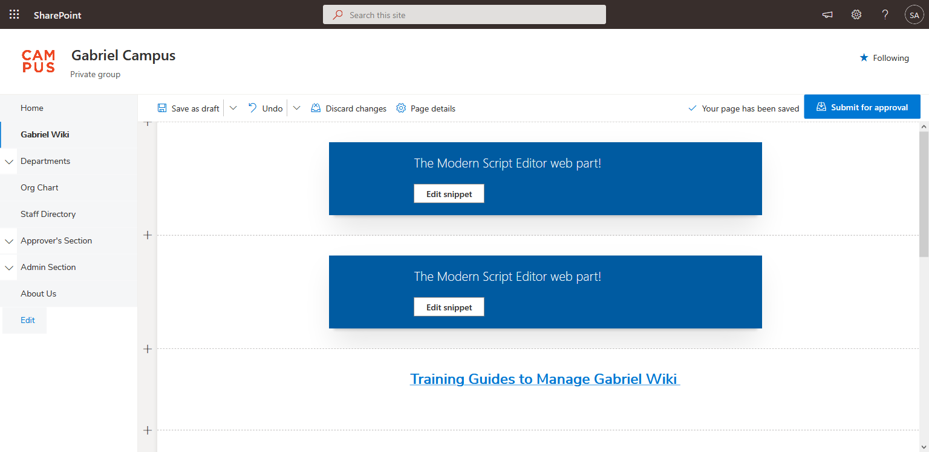
3. A modal popup will open with script code in it. Scroll down a little to find “.btn-<department>”.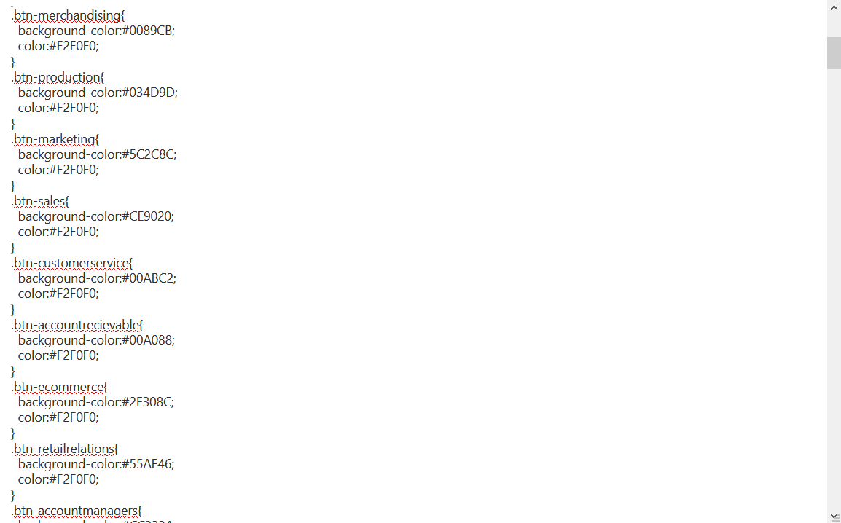
4. You can update colour by changing the hex colour as shown. Make sure the hex number of these matches with the department of wiki wheel. For example, for Sales department hex code colour is “#CE9020”. This will replace background colour with “#55AE46 as shown below.

.btn-sales{

background-color:#CE9020;

color:#F2F0F0;

}

Will become

.btn-sales{

background-color:#55AE46;

color:#F2F0F0;

}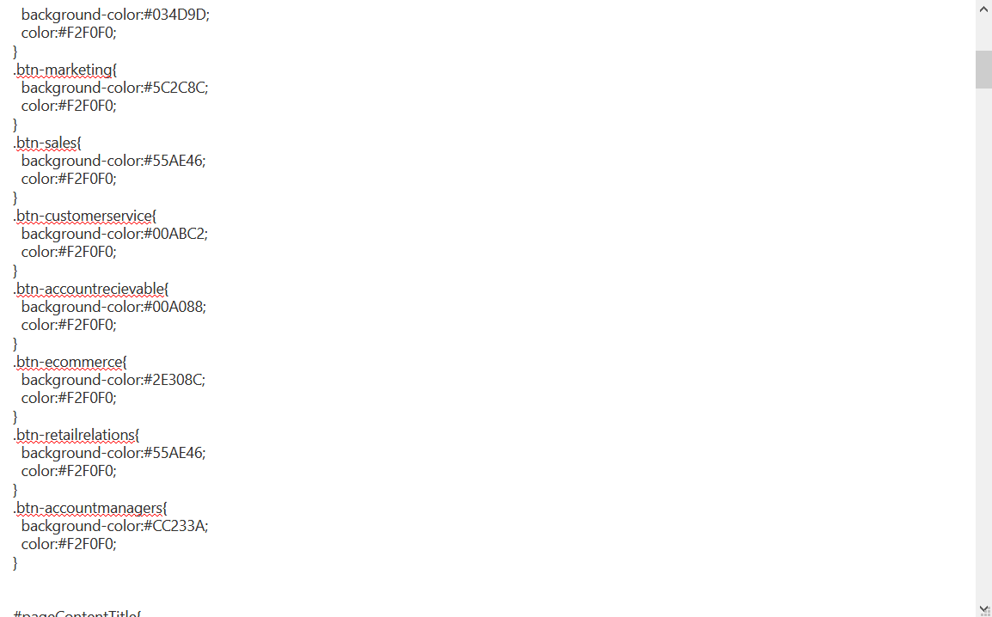

1. You will see impact on Preview portion below on Value Stream. To Add new value, copy the following code and paste below the script as shown.

.btn-<department>{

background-color: #<color-hex>;

color: #F2F0F0;

}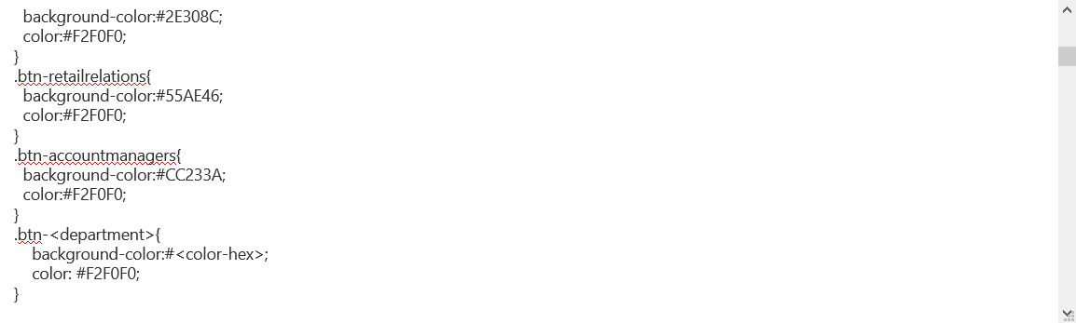

1. To apply these format, scroll down to bottom of script where you will find “<!-- VALUE STREAMS -->”. Here we can see stream titles and flow styles. For example here is the value stream of “CONCEPT TO PRODUCT” 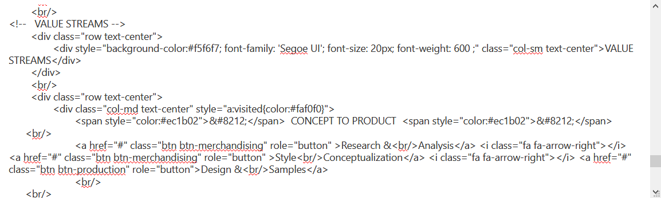

CONCEPT TO PRODUCT value stream

Value streams start here

Here tags like “.btn-merchandising” and “.btn-production” are used. These are the elements shown in earlier steps and they are used for color of boxes.

## Create New Value Stream

1. Go to bottom of the Scripts and copy a section of value stream and paste right below that section. Start copying from 1st “<br/>” to last “</a>” before ”</div>”.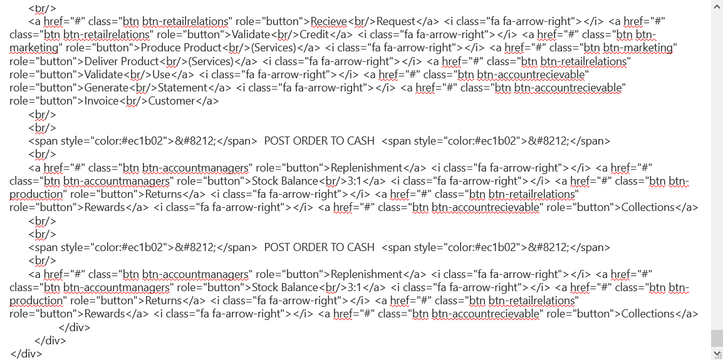

Paste

Copied

1. Change the title of the stream, .btn-<department>(with respective department name) and box text. 1``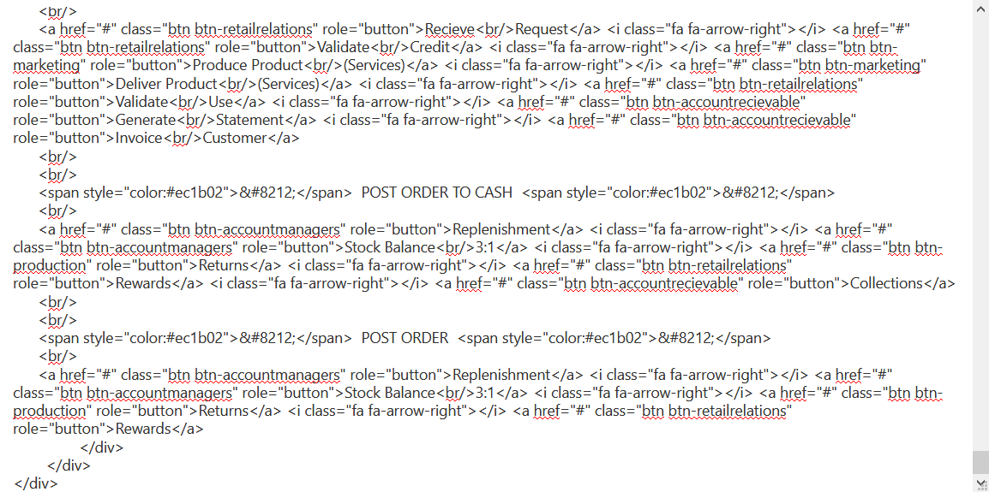 To remove extra boxes remove “<i class="fa fa-arrow-right"></i> <a href="#" class="btn btn-accountrecievable" role="button">Collections</a>” from the end. To add the box insert the code “<i class="fa fa-arrow-right"></i> <a href="#" class="btn btn-accountrecievable" role="button">Collections</a>. Make sure to change box text and btn-<department> respectively.

Box text

Title of the stream

btn-<department> for departments

1. Scroll at the bottom to preview and to apply changes press “Save” button. 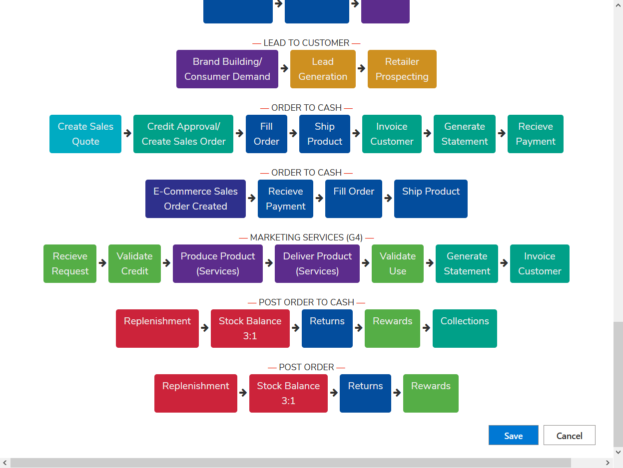

New Value Stream

1. Click on “Submit for approval”. It will show changes on page. 